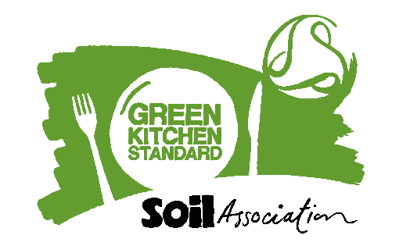
Suggested Website copy
Here at [site] we are proud that our caterers [insert catering company name] have achieved Green Kitchen Standard certification from the Soil Association for their sustainable kitchen practice.
Green Kitchen Standard certification recognises caterers that are taking positive steps to sustainably manage energy, water and waste and demonstrates their commitment to sustainable kitchen practice.
Green Kitchen Standard certified caterers run their operations in accordance with their energy, water and waste management policies and regularly monitor and set reduction targets.
Along with a food waste minimisation plan in place, facilities available for customers and staff to recycle and energy, water and waste considered in procurement, all these actions support continuous improvement in reducing their environmental impact.
[Insert short paragraph about your organisation. You could include information on how you met the Green Kitchen Standard standards and specific achievements you’d like to highlight.]
[Insert quote from caterer on what it means to achieve the certification and why this is important.]
Green Kitchen Standard certification recognises and celebrates caterers taking positive steps towards/demonstrating their commitment to sustainable kitchen practice.
Caron Longden, Head of Business Development for Healthy and Sustainable Food at Soil Association says:
Becoming Green Kitchen Standard certified is a great achievement showing caterers at the forefront of combatting climate change by reducing environmental impact. Through implementing best practice, monitoring energy, water use and waste, as well as setting improvement targets, Green Kitchen Standard shines a light on your hard work and showcases caterers leading by example.

Find out more about Green Kitchen Standard here www.foodforlife.org.uk/GKS

