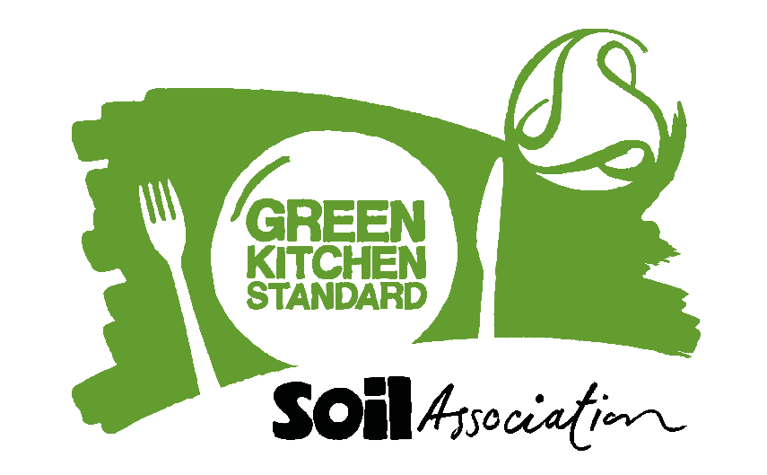

**Green Kitchen Standard certification - suggested copy for social media:**

Connect with Food for Life on [LinkedIn](https://www.linkedin.com/company/2409832/admin/?lipi=urn%3Ali%3Apage%3Ad_flagship3_feed%3Bmei4V5qIQnGk1xijBrGG5Q%3D%3D) and [X/Twitter](https://twitter.com/SAfoodforlife), or sign up for the [Food for Life Sustainable Catering](https://www.foodforlife.org.uk/about-us/contact-us/enewsletter-register) Newsletter to be kept up-to-date with all the recent industry and Food for Life catering news.

**Suggested copy –** *please feel free to adapt for your audience:*

1. We have achieved Green Kitchen Standard certification from @SoilAssocaition, this showcases we are taking positive steps to sustainably manage our energy, water and waste. Demonstrating our commitment to sustainable kitchen practice.
2. We have achieved Green Kitchen Standard certification from @SoilAssocaition. This shows we run our operation in accordance with our energy, water and waste management policies and regularly monitor and set reduction targets.
3. We have achieved Green Kitchen Standard certification from the @SoilAssociation demonstrating our commitment to sustainable kitchen practice.
4. We have achieved Green Kitchen Standard certification from the @SoilAssociation. Our actions support continuous improvement in reducing our environmental impact.