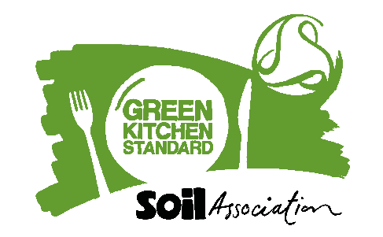

Suggested Newsletter text:
[Name of caterer] achieves Green Kitchen Standard certification from the Soil Association for sustainable kitchen practice
Our caterer, [insert name of caterer] has achieved Green Kitchen Standard certification.
Green Kitchen Standard certification recognises caterers taking positive steps to sustainably manage energy, water and waste and demonstrating their commitment to sustainable kitchen practices.
[Insert name of organisation] is striving to reduce their environmental impact by putting sustainability at the forefront of their food operations.
Green Kitchen Standard certified caterers run their operations in accordance with their energy, water and waste management policies and regularly monitor and set reduction targets.
Along with a food waste minimisation plan in place, facilities available for customers and staff to recycle, and energy, water and waste considered in procurement, all these actions support continuous improvement in reducing their environmental impact.
Caron Longden, Head of Business Development for Healthy and Sustainable Food at the Soil Association said:
Achieving a Green Kitchen Standard certification is a great achievement showing caterers at the forefront of combatting climate change by reducing environmental impact. Through implementing best practice, monitoring energy, water use and waste, as well as setting improvement targets, Green Kitchen Standard shines a light on your hard work and showcases the caterers leading by example.
For more information please visit www.foodforlife.org.uk/catering/green-kitchen-standard
Connect with Food for Life on LinkedIn and Twitter (X), or sign up for the Food for Life Sustainable Catering Newsletter to be kept up-to-date with all the recent industry and Food for Life Sustainable Catering news.

