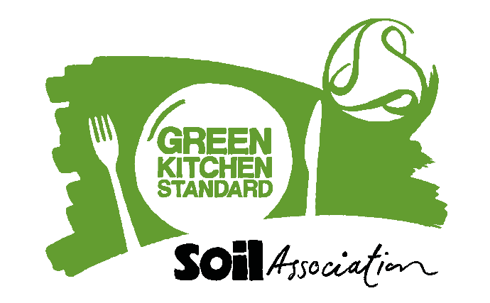

## Template Press Release:

**For immediate release**: [Date]

Word count:

Images attached: [up to 3 jpgs with captions – sent as attachments along with this press release]

**[Name of caterer] have achieved the Green Kitchen Standard certification from the Soil Association for their sustainable kitchen practice at [site].**

Green Kitchen Standard certification recognises caterers that are taking positive steps to sustainably manage energy, water and waste, demonstrating their commitment to sustainable kitchen practices*.*

Caterers who hold the Green Kitchen Standard have demonstrated that they:

* Have a food waste minimization plan
* Have energy, water and waste management policies and operate in accordance with these
* Set and regularly monitor reduction targets
* Provide facilities for customers and staff to recycle
* Consider energy, water and waste in procurement
* Have committed to continuously reducing their environmental impact

[Insert short paragraph about your organisation. You could include information on how you met the Green Kitchen Standard standards and specific achievements you’d like to highlight.]

[Insert quote from caterer on what it means to achieve your certification and why this is important.]

**Caron Longden, Head of Business Development for Healthy and Sustainable Food at Soil Association says:**

Becoming Green Kitchen Standard certified is a great achievement showing caterers at the forefront of combatting climate change by reducing environmental impact. Through implementing best practice, monitoring energy, water use and waste, as well as setting improvement targets, Green Kitchen Standard shines a light on your hard work and showcases caterers leading by example.

**- Ends -**

For further information, please contact:

[Please add your name, job title, phone number and email address, plus your company website address and any social media links your company use]

**Notes to editors:**

[Add some info about the history of your company here so that editors can add some background if they wish to.]

**A brief overview of Green Kitchen Standard:**

Green Kitchen Standard is part of the Soil Association’s Sustainable Catering portfolio of products and frameworks. The certification consists of mandatory standards:

* All sites are covered by energy, water and waste management policies and the catering operation is run in accordance with them
* A food waste minimization plan is in place and reviewed regularly
* Facilities are available for customers and staff to recycle

There is also a requirement to obtain points from a range of other standards within the sections/areas of; management and policy, communication (to both staff and customers), operating procedures, training and procurement.

[www.foodforlife.org/GKS](http://www.foodforlife.org/GKS)

**The Soil Association** is a UK-wide sustainable food and farming charity which aims to protect nature by transforming how people eat and farm. Since 1946 the organisation has impacted millions of people, creating practical, nature-based solutions to recover climate, nature and health through sustainable and regenerative food, farming, and forestry. We promote the connection between people, food, and the natural world, lobbying government on key environmental policies, helping to serve millions of certified school meals with [Food for Life](http://tracking.soilassociation.org/tracking/click?d=FdIK2s5P4cdwCYQeUmOzdJQUN_Sf9wvjilycEf-k2x8zOVIsuoPZri83JFo_EUjCr_8P7u617t9j0T5-qbBHZCuK9Ggm49kiCaPzrIKdnBO26klWqzyEat2teVXh0WZ-OQ2), engaging thousands in farmer-led research with [Innovative Farmers](http://tracking.soilassociation.org/tracking/click?d=cket12FfD6pQ1OsuJx7fx2IW-xOFpazqXBbMaNy7KZ33LzUw0wcxa1U7gA_GhK-gimDxIjz5x_3dkMkNakA18GDlA74LTVRglh9cJPSVzWf0-LT3yLOYkuidMCCiw11WvplZ9YUDgZLJvIgMOoLQ4tw1), and measuring the impact of sustainable farming with [Soil Association Exchange](http://tracking.soilassociation.org/tracking/click?d=GP9D3uYYYJCeDcUsu9Q8RniXbtwVF4C3vTw_E6C-048sPcfh0sEVgpvsJ7VVPlDwaj_iFyWdu4cOqMCnnzhhAhQv4_SNm9f7Gb-vYH56PXDQS8-AHC6LJ34EaC_ucYkyada-gPfXIAjCdWVesCJABsY1). We have a network of spokespeople on farming and food topics who can provide expert comment and share their experiences. This includes organic farmer Helen Browning OBE, who is Chief Executive of the Soil Association Group.

To find out more visit [www.soilassociation.org](http://www.soilassociation.org/)